Link: <https://github.com/44-563-Web-Apps-F22/44563-webapps-assignment-7-donthireddylokeshreddy>

S550520

Screen shot 1 of repo on VS Code for submission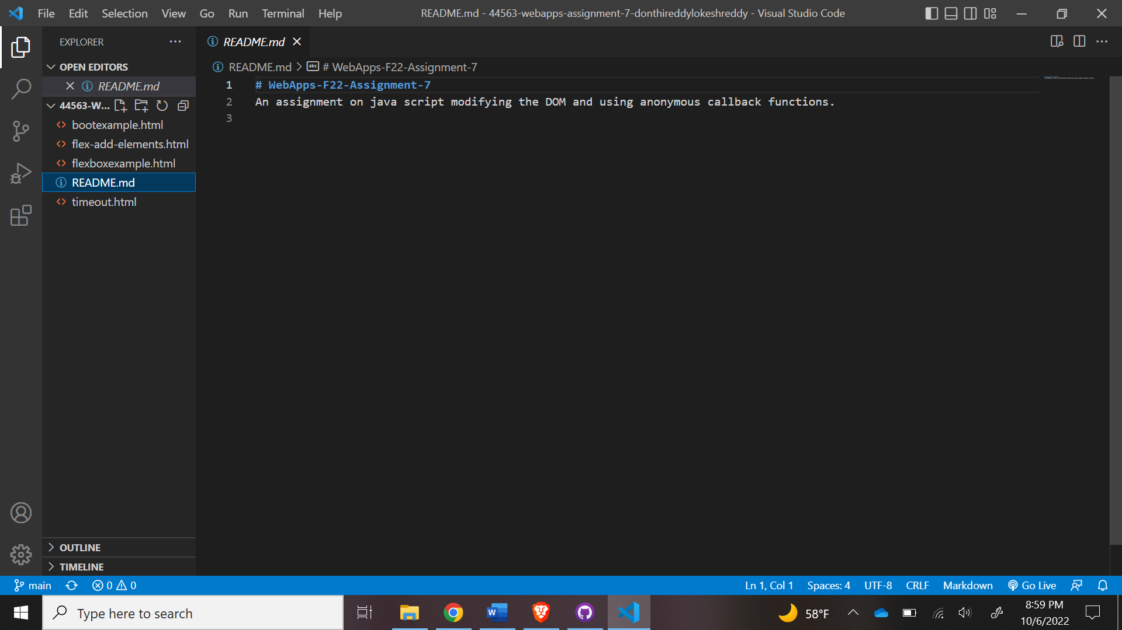

Screen shot 3 on browser

